[](https://www.google.co.uk/url?sa=i&rct=j&q=&esrc=s&source=images&cd=&cad=rja&uact=8&ved=0ahUKEwjsnof25ufVAhVDlxQKHcjMC6QQjRwIBw&url=https://www.v-academy.com/memory-enhancement-strategies-for-police-training/&psig=AFQjCNGK9DO-jQjj5RnC7-QTGvOaVk_DAw&ust=1503386842564382)

**Memory Skills Workbook  
Session 3 & 4: External & Internal Memory Enhancement Strategies**

**Course Overview**

Session 1 Introductions and an overview of cognitive abilities

Session 2 Overview of memory

**Session 3 External & Internal memory enhancement strategies**

**Session 4 Internal memory enhancement strategies**

Session 5 Mood and cognitive functioning

Session 6 Keeping well, course reviews and goodbyes

**Introduction**

Coping with memory problems can be difficult and requires making new adjustments to your life and way of doing things. But if used consistently, there are lots of different strategies that can help us to recall information. These can be divided into internal strategies and external strategies.

Today we will be talking about external memory enhancement strategies and communicating our difficulties to others. We will be talking about internal strategies in the next session.

**Mindfulness**

As we said in the last session, when you come into each session there may be lots of things on your mind. You might have thoughts about what you’ve been doing, what you need to do; maybe some expectations or perhaps worries about what the group itself will be like. Our minds often wander and life is sometimes filled with stresses or worries.

To start off today, and at the beginning of our future sessions, we will carry out a brief mindfulness exercise. The aim of this is just to help us be more present ‘in the moment’, and give us some time to become more aware of our thoughts, feelings and any physical sensations. As we’ll see later in the course, this can also support our cognitive functioning and help our memory along with promoting overall well-being.

[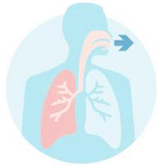](https://www.google.co.uk/imgres?imgurl=https://www.lung.ca/sites/default/files/Breathing_icon2.png&imgrefurl=https://www.lung.ca/lung-health/lung-info/breathing&docid=KxhkevRTieIz0M&tbnid=7VtVH5pe_6XcvM:&vet=10ahUKEwjhlvma6ufVAhUpDcAKHQLRAx84ZBAzCDooODA4..i&w=245&h=250&bih=908&biw=1116&q=breathing%20&ved=0ahUKEwjhlvma6ufVAhUpDcAKHQLRAx84ZBAzCDooODA4&iact=mrc&uact=8)If you have difficulty focusing on the breath (e.g. due to breathing difficulties) then go at a pace that feels comfortable to you, stop the meditation or focus on another part of your body, such as your feet.

**Exercise 1: Communicating my Difficulties to Others**

Having memory difficulties can impact on our lives in lots of different ways, including our relationships, work, mood and general wellbeing.

A common problem for people with memory difficulties is thinking about whether and how we might tell other people about our difficulties. As a group, we will be thinking about the pros and cons of telling people about our memory difficulties and how this impacts on our lives.

If you want, you can use the table on the following page to jot down the pros and cons.

[](https://www.google.co.uk/url?sa=i&rct=j&q=&esrc=s&source=images&cd=&cad=rja&uact=8&ved=0ahUKEwjE-dmu8OfVAhUFDxoKHUlgDk4QjRwIBw&url=https://www.klejonka.info/2017timage-two-people-talking-clipart.awp&psig=AFQjCNHtsXpr0X4hLs09q2ZKczaNjlUY3Q&ust=1503389338216790)

|  |  |
| --- | --- |
| **Pros** | **Cons** |
| _______________________________  _______________________________  _______________________________  _______________________________  _______________________________ | _______________________________  _______________________________  _______________________________  _______________________________  _______________________________ |
| **Think about who it might be useful for us to share our memory difficulties with.** *You can use the space below to make a note of the group discussion.*  ______________________________________________________________  ______________________________________________________________  ______________________________________________________________  ______________________________________________________________  ______________________________________________________________ | |
| **Sometimes it can be difficult to know how to communicate the impact of our difficulties with others.** *Have a think about how we might do this and jot it down in the space below.*  ______________________________________________________________  ______________________________________________________________  ______________________________________________________________  ______________________________________________________________ | |

**What are External Strategies?**

External strategies are used to help us compensate for difficulties with our memory. These strategies involve making external changes within our environment.

**Visual aids**

If you’re likely to remember things that you see, use pictures, drawings and photographs. These can help us to encode and store information into our memory as well as prompt our memory later on.

[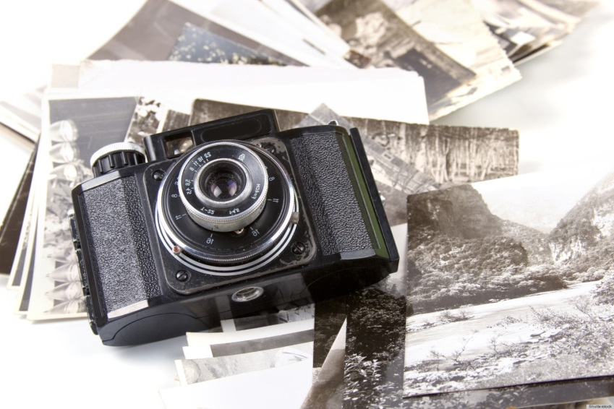](http://www.google.co.uk/url?sa=i&rct=j&q=&esrc=s&source=images&cd=&cad=rja&uact=8&ved=0ahUKEwics5ys8efVAhWDyRoKHYe9CvUQjRwIBw&url=http://www.huffingtonpost.com/gretchen-rubin/photographs-can-boost-your-happiness_b_3210947.html&psig=AFQjCNEXm_F1w08VTwNTMTYkltlRUzpxhQ&ust=1503389730384322)

**Verbal aids**

[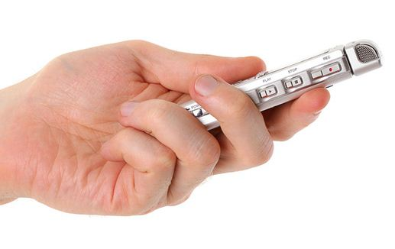](http://www.google.co.uk/url?sa=i&rct=j&q=&esrc=s&source=images&cd=&cad=rja&uact=8&ved=&url=http://www.bridiestypingservices.com/outsource-your-transcription/dictaphone-3/&psig=AFQjCNHIP1eRwQeOWsFLENAt7g4ucIRccA&ust=1503390089161354)If your memory is better for information that you hear it might be useful to use a Dictaphone to describe events of the day, record lectures or meetings or just to make a note of something important. This can also help us to encode and store information into our memory and that way if you forget you can listen   
 back to the information to help to jog your   
 memory. There is also computer software   
 and audio versions of books which you can use to   
 listen to information rather than relying on reading it.

**Get organised!**

Getting organised at home is very important for memory. There are lots of different aids that can help us become more organised. If used consistently these aids can make life much easier and puts less strain on your memory. Below are some examples:

* ***Folders/files:*** Make folders and files for important papers, bills, recipes etc. so they’re easier to locate.
* ***Sort it*:** everything should have its place. Sort drawers, cupboards, shelves etc.
* ***Label it*:** use labels on drawers, doors, cabinets, files, boxes etc. That way you and others in your house will find it easier to locate and put things away.
* [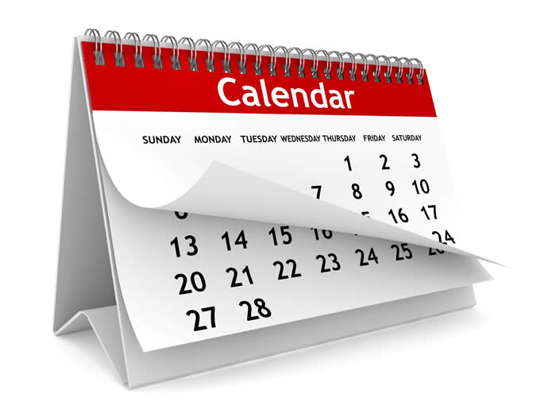](http://www.google.co.uk/url?sa=i&rct=j&q=&esrc=s&source=images&cd=&cad=rja&uact=8&ved=0ahUKEwiKpqWO9OfVAhUHPxQKHaFpAV0QjRwIBw&url=http://www.drk.sd23.bc.ca/About/Calendar/Pages/default.aspx&psig=AFQjCNFdzyoLaYDdVsliSmp1MGvdl3CmDg&ust=1503390478378857)***Diary/Filofax***: using a diary or Filofax can be helpful for remembering what you need to do.
* ***Charts/calendars***: Charts and calendars can also be useful for remembering what you need to do. Making these visible around the house is also useful because it helps us to pay attention to them.

**Boards**

Hanging boards, blackboards or bulletin boards can be helpful for remembering information. These can be strategically placed around the house for remembering information (e.g. in the hallway or on the fridge). You could use this for to do lists, shopping lists, for events or simply to jot down important information.

[](https://www.google.co.uk/url?sa=i&rct=j&q=&esrc=s&source=images&cd=&cad=rja&uact=8&ved=0ahUKEwiXjtG_9OfVAhUDuxQKHRseCdYQjRwIBw&url=https://play.google.com/store/apps/details?id%3Dcom.markspace.fliqnotes&psig=AFQjCNGcab0_l68jDF-Gj7aWh2Zf4zhlfA&ust=1503390577088054)**Notes**

Take notes of what you need to remember but try to keep it in one place (i.e. a note pad) so you remember to look. You might want to keep a daily list of what need to remember. It’s important to write enough that you understand what you need to remember but not too much that it becomes overwhelming and counterproductive. We will demonstrate this later on.

**Journal**

A journal can be useful for reflecting back on your day or checking what you did during the day later on if you’re unsure.

**Post it notes**

Leave post it notes to remind you of things in places that you know you’ll look. For example, you might want to remind yourself to lock the door when you come in at night by putting a post it note next to the door.

**Cues**

Leaving cues around the house or in other places can also help to jog your memory. For example, if you leave your notebook by the kettle you might be more likely to pick it up in the morning.

**To do lists**

It might be worth creating a daily ‘to do’ list of things you need to do. You can add to this throughout the day and tick off when each task has been completed.

[](https://www.google.co.uk/url?sa=i&rct=j&q=&esrc=s&source=images&cd=&cad=rja&uact=8&ved=0ahUKEwiukrrn9efVAhXDiRoKHR_DCLkQjRwIBw&url=https://blog.hubspot.com/marketing/organize-to-do-list&psig=AFQjCNHQvEjxHVyVJyH10yPzNWUPc6bG-Q&ust=1503390918630760)

**Environment**

Try to eliminate background noise as much as possible to reduce distraction. Turn off the TV or radio and close doors if people are talking. Getting rid of clutter can help to reduce visual distraction. This will help you to have more focused rather than divided attention.

**Technology**

With technology continuously changing, new memory aids are constantly developing. Below are some examples of these:

* **Location detection devices:** These can be useful if you if you misplace/forget where important things are. They can be attached to keys or other important devices and make a loud sound to help you find it. Mobile phones can also be linked to family and friends so they know your whereabouts if you’re worried getting lost
* **Tablets/computers:**  Also have similar functions to smart phones but are slightly bigger. You can ‘sync’ your devices (share your information and apps between your phone/computer/tablet). This can be useful if other people need access to your information or you use more than one device for different things (e.g. at work, home or when you’re out).
* **Satellite Navigation (SATNAV):** Can be used if you have difficulty remembering routes. Navigation systems are also available on phones and tablets.
* [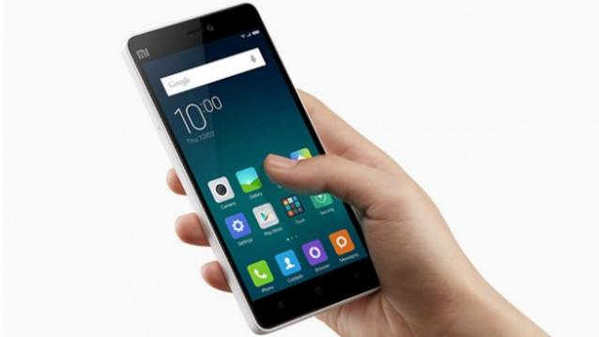](http://www.google.co.uk/url?sa=i&rct=j&q=&esrc=s&source=images&cd=&cad=rja&uact=8&ved=0ahUKEwiE37qE9-fVAhXKExoKHTlPC64QjRwIBw&url=http://junaids-first-project-80859f.webflow.io/&psig=AFQjCNFSYMjVNwEJvomq7w1-K4m3VfuG_Q&ust=1503391219717168)**Phones:** Phones have a number of useful features including calendars, alarms and reminders.Smart phones have a number of additional apps and features that can be helpful for remembering information. This includes budgeting tools and notes pages for writing lists. Some phones even have ‘memory aid apps’ which incorporate lots of different strategies to help your memory.

**Difficulty**

When learning something new you should try to pace yourself and start off with simple tasks, gradually increasing their difficulty and length of time spent on the task. This will also help to gradually train your attention.

**Timing**

Are you a morning person or do you function better later in the day? Try to schedule activities which put higher demands on your attention and memory for the time of day when you perform the best.

**Slow down**

When doing new things or tasks that you know will put high demands on you plan ahead and take your time. For example, if people are talking too quickly or if you don’t understand something ask them to slow down or repeat the information.

**Breaks**

[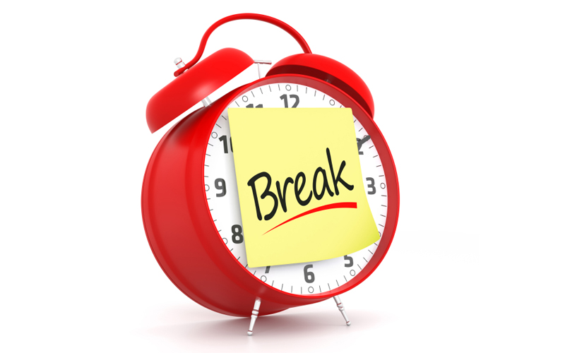](http://www.google.co.uk/url?sa=i&rct=j&q=&esrc=s&source=images&cd=&cad=rja&uact=8&ved=0ahUKEwiipf3K-OfVAhXMbRQKHZg-AZAQjRwIBw&url=http://www.friendshipcircle.org/blog/2012/10/19/how-and-when-to-give-your-students-with-special-needs-a-break/&psig=AFQjCNFKX9CzCccKFysMk8U-ZT660tQw_w&ust=1503391669666601)Ensure that you take regular breaks when learning something new. This will help to take the pressure off your concentration and minimise tiredness and frustration caused by overexerting yourself. It’s also useful to give yourself rewards to look forward to.

**Routine**

Maintaining a good routine is very important for memory. This is because when something becomes part of our routine it put less pressure on our memory and becomes part of our procedural memory (our long term memory of how to perform different actions or skills). These types of memories are so ingrained they usually become automatic which is why they put less pressure on other types of memory or our attention.

**Context**

Sometimes it’s easier to retrieve information if we’re in the same place, situation or mood we were in when we learned that information. If you’re having trouble remembering something it might be worth going back to the place or situation you encoded it.

**Creating my memory ‘tool box’**

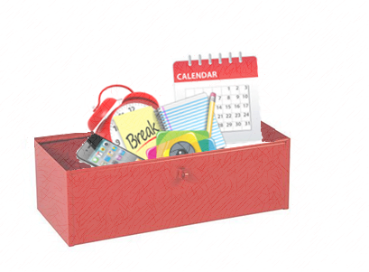It’s useful to start off by making a plan of which strategies would be useful for you and when you aim to start implementing each strategy. Try to focus on one strategy at a time. Remember that it takes time for strategies work and become part of our routine so try to be patient and stick with the strategies even if you feel they’re not working straight away.

**How do I Know which Strategies will be the Most Useful for Me?**

When deciding which strategies are the most useful for you, ask yourself questions about what exactly the problem is.

**Do I have a specific difficulty with my memory?**

Think about whether there’s a specific difficulty with your memory. For example, is it that you’re forgetting what you need to do? Are you forgetting names? Are you having difficulty recognising faces? Then focus your strategies on these difficulties.

**Do I remember information better when I see or hear things?**

If you’re better at remembering visual information, try to incorporate as many visual aids into your plan such as pictures, diagrams or photos. If you’re better at remembering verbal information use verbal aids such as saying things out loud or using a Dictaphone.

**Do I forget things shortly after they’ve happened or after an extended period of time?**

[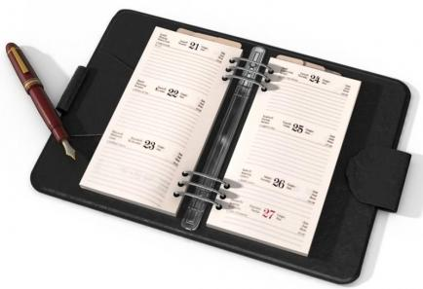](http://www.google.co.uk/url?sa=i&rct=j&q=&esrc=s&source=images&cd=&cad=rja&uact=8&ved=0ahUKEwjDweaq_-fVAhWCzxoKHbaqAz4QjRwIBw&url=http://yaq.es/reportajes/gestion-del-tiempo-3-sencillos-pasos&psig=AFQjCNEYI-9sDw0sRcWSSbh7kGNhlBcWog&ust=1503393429099998)If you’re likely to forget things straight away, use the strategies immediately. E.g. put things in your diary straight away, write your lists straight away etc. If you’re likely to forget things over an extended period of time think ahead! Take photos, write things down important information etc.

**Are you having a specific difficulty during the process of learning?**

Think about the process of learning new information (see session 2) and try to identify where you’re having difficulty. Is it that you’re getting distracted and not paying attention? Do you feel as though you’ve slowed down a bit? Are you having trouble encoding, storing or retrieving the information? Try to focus your strategies on the different stages of this process. For example, if you’re having difficulty with your attention try to focus on one task at a time, clear external clutter and take regular breaks. See the table below for more information on this.

[](https://www.google.co.uk/url?sa=i&rct=j&q=&esrc=s&source=images&cd=&cad=rja&uact=8&ved=0ahUKEwivpaafgejVAhXEuhQKHUUYB9IQjRwIBw&url=https://www.videoblocks.com/video/elderly-woman-with-a-cup-of-hot-tea-and-an-open-book-relaxing-on-nature-in-autumn-park-4p9b1-pcgikjxzr1p/&psig=AFQjCNGHqWIiogs8K8tLINFj19aa74OZVg&ust=1503393962381902)

**Other useful tips**

* Try to incorporate the strategies into your routine. That way you won’t be relying so much on remembering and it will become part of your procedural memory (your automatic memory for doing things).
* Incorporating strategies into your life and routine can take time. Give yourself time to adjust!
* Don’t try to do too much at once. When implementing new strategies try to do one at a time. That way you’re more likely to remember and incorporate it into your routine.
* Keep track of your progress. Keep a diary of all the strategies you’re implementing and monitor your progress over a month or a week. That way you can also review whether those strategies are working for you.

**Table 1.** Strategies for each stage of the process of learning and remembering.

|  |  |
| --- | --- |
| **Stage** | **Strategies** |
|  |  |
| **Attention** | * Visual aids to help pay attention   (e.g. wall charts/calendars).   * Get organised * Notes * Journal * Post-it notes * Cues * Technology * Boards * Alerts/reminders * Focus * Environment * Slow down * Take breaks * Timing * Difficulty * Routine |
|  |  |
| **Information Processing** | Visual aids   * Verbal aids * Get organised * Boards * Notes * Journal * Post-it notes * Cues * technology * Slow down * Take breaks * Timing * Difficulty * Focus * Environment * Routine |
| **Encoding and**  **Storage** | * Visual aids * Verbal aids * Get organised * Boards * Notes * Journal * Post-it notes * Cues * Technology * Slow down * Take breaks * Timing * Difficulty * Focus * Environment * Routine |
|  |  |
| **Retrieval** | * Visual aids * Verbal aids * Get organised * Boards * Notes * Journal * Cues * Post-it notes * Technology * Slow down * Take breaks * Timing * Focus * Environment * Routine * Context |

**How can I effectively utilise external memory aids?**

It’s important that we use our memory aids effectively in order for them to work. There are some examples of effective and ineffective use of strategies on the next couple of pages.

Here are some tips for utilising external memory enhancement strategies effectively:

* Keep it simple. Focus on the main bits that you need to remember.
* Don’t write too much or too little. It’s important to write just enough to help jog your memory later on.
* Don’t overload your mind with visual and verbal information because when you read over it will be too overwhelming for your mind to take it in and visualise later on.
* Use visual and verbal aids wherever possible to aid memory.
* Organise your notes on the page so it’s easy to visualise later on.

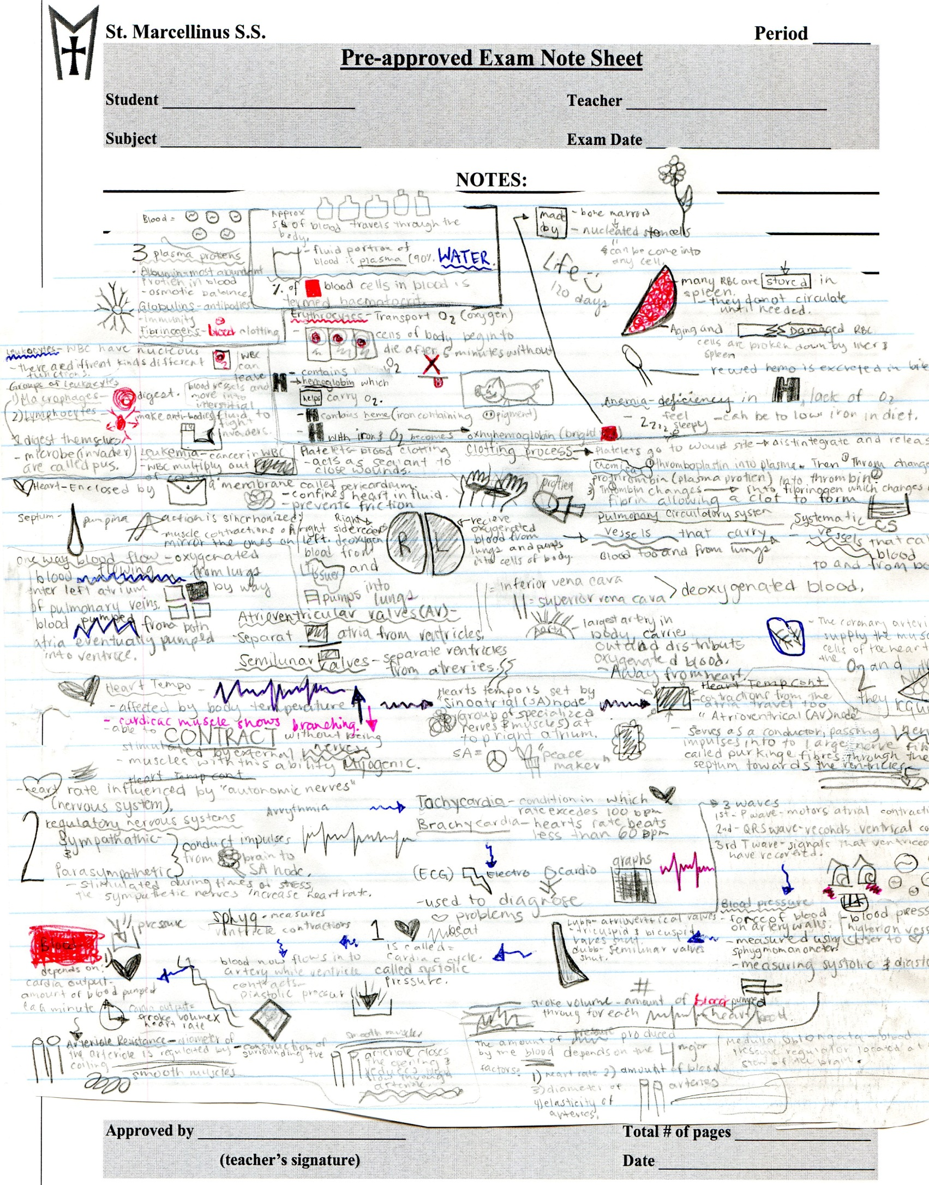**Example 1: ineffective note taking**

As you can see this page is overloaded with both visual and verbal information

**Example 2: Efficient note taking**

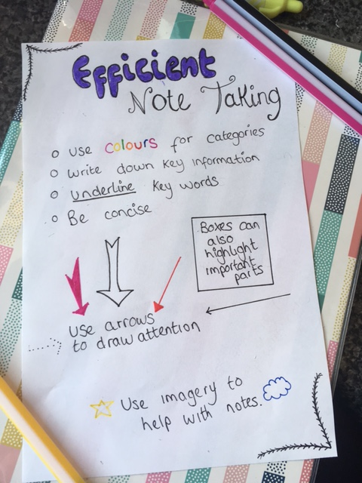

This example is more effective because it’s simple, uses colour and pictures and is organised well on the page.

**Internal Memory Enhancement Strategies**

As we’ve said, internal memory enhancement strategies are strategies that we use within our minds to aid memory.

An outline of some of these strategies is provided below.

**Brain Exercise**

Keeping our brains active is very important for ensuring our minds stay healthy by training and keeping the pathways in the brain active. This might include doing crosswords, Sudoku, puzzles and arithmetic.

**Chunking of Information**

Rather than trying to remember a whole phone number or list such as 1485968704, chunk the numbers into 148-596-8704.

[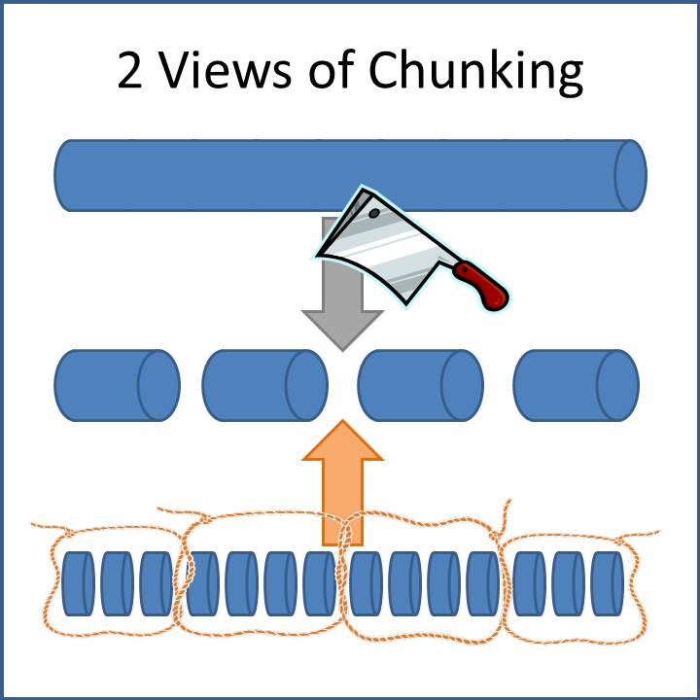](http://www.google.co.uk/url?sa=i&rct=j&q=&esrc=s&source=images&cd=&cad=rja&uact=8&ved=0ahUKEwju1e-XlObWAhUQK1AKHeE2BB0QjRwIBw&url=http://presentationswithresults.com/are-you-chunking-your-content/&psig=AOvVaw3xD09P6r6OaiKwSfEQ20eu&ust=1507728384029746)

**Repetition**

When trying to encode information into you memory, rehearse it.

You can do this by either repeating it out loud or in your head.

[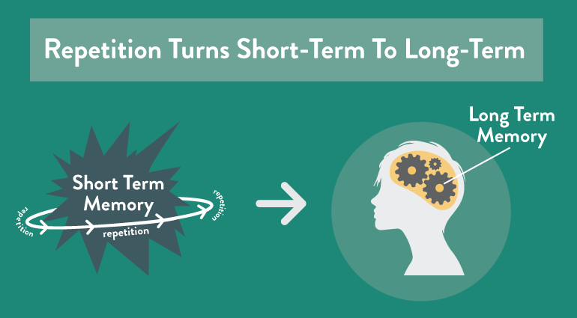](https://www.google.co.uk/url?sa=i&rct=j&q=&esrc=s&source=images&cd=&cad=rja&uact=8&ved=0ahUKEwiF8MHTxOjVAhVESRoKHfC5CqAQjRwIBw&url=https://coschedule.com/blog/memory-techniques/&psig=AFQjCNGBWrZ2SyE5KsUv01gZZ9DqDgeDsQ&ust=1503412095760996)

**Grouping**

Grouping information together into categories can aid recall because it makes information more meaningful. For example, if you need to remember a shopping list it might be useful to group items into fruits, vegetables etc.

**Breaking down tasks**

When learning how to do something new it can be helpful to plan and break the task down into smaller steps. Write these steps down so you can refer back to them next time you do that task. For example, if learning how to cook a new dish you might break down the task into smaller sections; write a checklist of all the ingredients I need, write a list of all the utensils I need, take out the ingredients, take out the utensils, turn on the oven etc. This will help you to attend to each aspect of the task and consolidate learning.

**The PQRST method**

The PQRST method is used to help improve our memory for information that we read. Reading is usually quite a passive way of learning but PQRST helps us to remember better by making the process more active.

Each letter stands for a different stage in this process:

**P stands for PREVIEW:** You should preview the text that you are going to read by quickly skimming through it. This will help you to get an idea of what the text is about.

**Q stands for QUESTION:** Next you should ask yourself questions about the text. E.g What is it about? Who are the main characters? What am I supposed to learn from this? You can write these down if needed.

**R stands for READ:** Read the text, keeping the questions you asked yourself in mind. This will help you focus on the most important areas.

**S stands for SUMMARY:** Summarise the key points of the text. Ask yourself what was it about? Did it make sense to you? Do I need to reread anything?

**T stands for TEST:** Test your knowledge of it, you can do this by asking yourself the questions you thought of earlier and see if you’re better able to answer them now. This will help you to consolidate the information.

**Making Associations**

Making associations between something you need to remember and previous knowledge can help us to make the new information more meaningful and we therefore remember it better. This includes:

* Remembering to do a new activity by linking it to an existing one. For example, taking medication at meal times
* Learning a new name by associating it with something or someone you already know. For example, you might remember the name Angela by thinking of an angel.
* Leaving an item associated with an activity visible so you remember to do it. E.g. leaving the boots by the door so you remember to take the dog for a walk.

[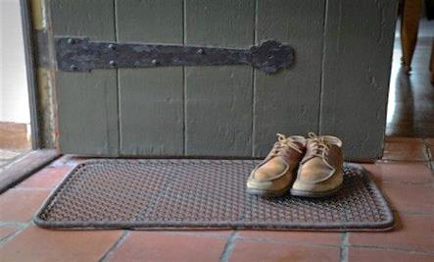](https://www.google.co.uk/url?sa=i&rct=j&q=&esrc=s&source=images&cd=&cad=rja&uact=8&ved=0ahUKEwig3o3nyOjVAhXGOxQKHRhIDFUQjRwIBw&url=https://livehealthyosu.com/2016/04/07/leave-your-shoes-at-the-door-please/&psig=AFQjCNEj7Aq59PNaD6VP_w-a9ilBomf4tA&ust=1503413159684485)

**Mental Retracing**

If we’re struggling to remember something, retracing our movements, activities and thoughts in our heads can be helpful.

**Stories**

Making up stories can be useful for remembering things. For example, if you had a shopping list of weetabix, milk, jam, teabags and toothpaste you might create a story like ‘In the morning I get up and have my Weetabix with milk and jam then I have a nice cup of tea before I brush my teeth’.

[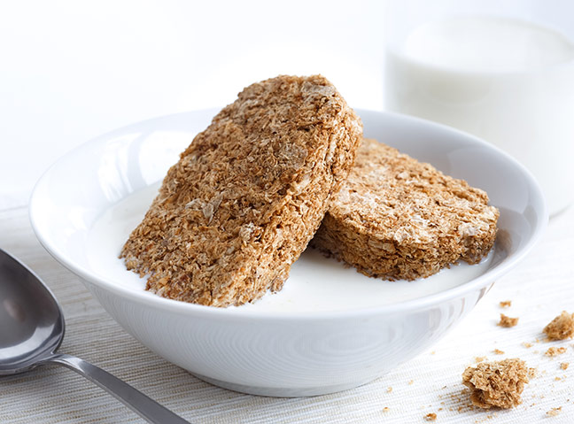](http://www.google.co.uk/url?sa=i&rct=j&q=&esrc=s&source=images&cd=&cad=rja&uact=8&ved=0ahUKEwi8yK2gy-jVAhXIxxQKHV-SDbYQjRwIBw&url=http://www.womanandhome.com/news-and-entertainment/541944/supermarket-own-brand-weetabix-ludicrously-similar-to-branded-product&psig=AFQjCNFM6EGnX9pNPbi9coSONwxAySPECg&ust=1503413851895471)

**Visual Imagery**

The use of visual imagery can be very helpful for learning and remembering information. Below are some examples:

* **Things to do -** If you need to complete a task like posting a letter, you can imagine yourself doing that task. By making the association between the post-box and the action of posting the letter you’re more likely to remember to do it.
* **Routes –** If you need to remember a new route it can be useful imagining yourself walking the route.
* **Peg Method**

**Peg Method**

This method uses two memory strategies to help you remember information. It uses **‘association**’ and **‘visualisation’**.

The idea is that you will ‘hang’ one piece of information on each peg.

Following the steps below to set up your pegs:

1. Number your pegs in order, e.g. 1 2 3 4
2. Write down a word that rhymes with each number. This works best if the word can be easily pictured in your mind, e.g. two = shoe

One: ____________   
  
Two: ____________

Three: ____________

Four: ____________

1. What does each word look like as a picture in your mind, e.g. is it cartoon, is it colour, how big is it? Can you draw this in the box?
2. Repeat the paired numbers/words aloud until you feel confident with them
3. Repeat the paired numbers/words in your head and as you do this, visualise the words as pictures in your mind
4. Imagine you need to remember to phone a friend later today. Use your imagination to associate a visual image of phoning a friend, with the visual image of peg one.

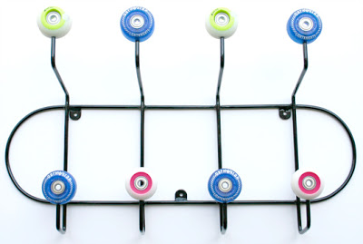

**Useful Internal Strategies for each stage of the Process of Learning and Remembering.**

|  |  |
| --- | --- |
| **Stage** | **Strategies** |
| **Attention** | * Mindfulness meditation * Breaking down tasks * Making associations * Visual imagery * Peg method |
| **Information processing** | * Making associations * Visual imagery |
| **Encoding and storage** | * Chunking * Grouping * PQRST * Repetition * Expanding rehearsal * Making associations * Stories * Visual imagery * Peg method |
| **Retrieval** | * Mindfulness meditation * Mental retracing * Making associations * Replacing numbers * Visual imagery |

**Out of Session Work:**

**Implementing my Memory Enhancement Strategy**

Between now and the next session we would like you to start implementing the strategy that you have chosen.

It’s important to remember that it takes time for strategies to start working so we should try not to have expectations about the effectiveness of the strategy.

**Out of Session Work:   
Putting Together my Memory Strategy ‘Toolbox’**

Complete the flowchart below to identify which strategy might be helpful for you. Remember it takes time for strategies to work and different strategies work for different people.

1. Choose one memory difficulty that you would like to focus on:

*It might be useful to look over the memory strategy sheet you completed after session 1.*

I would like to focus on: __________________________________________________

**2.** Which part of the memory process might be causing this difficulty?  
*It might be useful to look over the memory self-assessment 2 sheet you completed after session 2.*

My main area of difficulty is: ______________________________________________

**3.** What are my cognitive strengths?   
*You might want to look over memory assessment form 2 for this.*

My strengths are: _______________________________________________________  
  
_____________________________________________________________________

____

4. Choose a strategy that we discussed today that might help with your difficulty.

*Try out this strategy over the next week and we will discuss how it went over the next week.*

External memory enhancement strategy: ____________________________________

|  |
| --- |
| Use the space below to write notes if needed: |
|  |
|  |
|  |
|  |
|  |
|  |
|  |
|  |
|  |
|  |
|  |
|  |
|  |
|  |
|  |
|  |
|  |
|  |
|  |